* **Team member**

| **Full name** | **Roll number** | **Position** | **Phone Number** | **Email** |
| --- | --- | --- | --- | --- |
| Hoàng Anh | C2010G0141 | Member | 0988869520 |  |
| Vũ Đức Anh | C2108L0272 | Member | 0975502334 |  |
| Nguyễn Đình Duy | C2105L0183 | Leader | 0368415649 |  |
| Phạm Đăng Đức | C2108L0255 | Member | 0582017203 |  |
| Nguyễn Trung Đức | C2108L0265 | Member | 0836710765 | duc.nt.1940@aptechlearning.edu.vn |

* **Background**
* For each person and each family, a car is not only a means of transportation but also a major family asset and not every family can afford it. Not only that, some families, although well-off and able to buy a car, still choose to use self-driving car rental services because it brings many conveniences.
* Nowadays, car prices are increasing very rapidly, compared to the average income of each person, owning a car is very difficult. Based on the news website (https://baotintuc.vn), car prices in 2023 have increased 2.5 times compared to the market price of previous years, leading to workers gradually shifting to renting self-driving cars. According to Mordor Intelligence, the self-driving car rental market in Vietnam is valued at 463.19 million USD in 2021, and is expected to reach 884.71 million USD in 2027 with a compound annual growth rate of 13.82% in the period 2022 - 2027. Meanwhile, according to Statista, the revenue of the self-driving car rental market in Vietnam in 2023 is expected to reach 0.92 billion USD. In addition, the revenue of this market is expected to reach 1.19 billion USD by 2027 with a compound annual growth rate of 6.57% in the period 2023 - 2027.

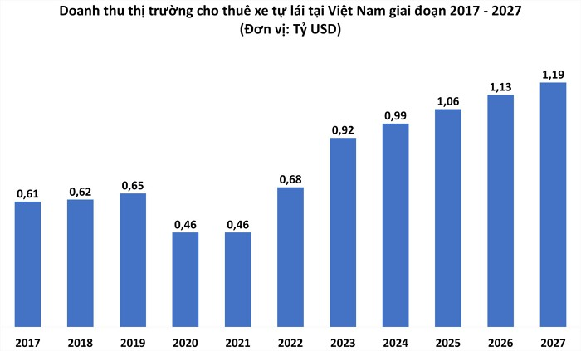

Doanh thu thị trường cho thuê xe tự lái tại Việt Nam giai đoạn 2017 - 2027. (Nguồn: *Statista - Doanh Chính tổng hợp*).

* Combining the importance and popularity of the self-driving car rental service industry, our goal is to bring the fastest, smartest, and most convenient convenience to users who want to access the extremely hot service industry.
* **The system existing**
* Below are some of the systems already available.

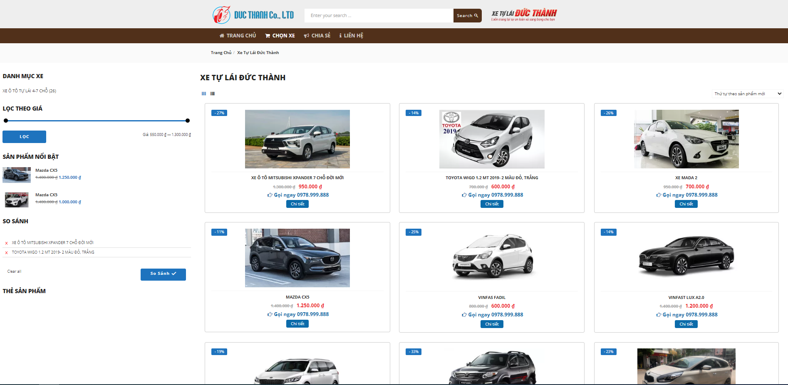

***FIRGUE 1-1*** *XE TỰ LÁI ĐỨC THÀNH*

*(* [*https://xetulaihanoi.vn*](https://xetulaihanoi.vn) *)*

* Website **XE TỰ LÁI ĐỨC THÀNH** is a website that provides online car rental services and compares car prices.

| * **Pros:** * Easy to use. * accurately and quickly * Support for search, sorted. * Personalized. * Information is accurate and reliable. | * **Cons** * Many administrative procedures |
| --- | --- |

## 

## **Purpose**

* This report is a guide to regulation and supervision of organization and plan of the project. It describes an overview of the project include proposed system, boundaries and development environment of the capstone project. The ultimate purpose of Project management plan is to clearly deﬁne the roles, responsibilities and the processes of team member to assign tasks and deadlines.

## **Problem definition**

### **Name of this Capstone Project**

### **Project Name:**

### **Project code:**

### **Project category**:

### **Product type**:

### **Time line:**

### 

### 

### **Tools and Techniques**

1. **Tools**

* **Version Control Systems:** Git 2.13.0 or higher, SourceTree.
* **Source Code Management Systems:** GitHub.
* **Project Management Tools:** Microsoft Office 2016 (Word, Excel, PowerPoint).
* **Diagram Tools:** https://app.diagrams.net ( website ).
* **Design Tools:** Photoshop CC 2019.

#### **Techniques**

* **Programming languages:**
* HTML5/CSS
* C#
* JavaScript

### **Software Process Model**

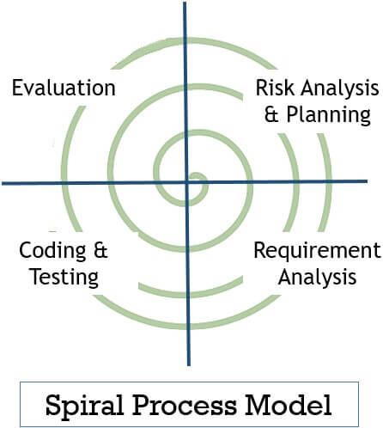

1. **Planning**This phase includes the planning process, tasks, resource defining, team planning, timelines and gathering of other project related information. Planning phase includes the estimating costs, schedule for iteration. Once the planning finalizes the team proceed to the next step i.e., Risk Analysis.
2. **Risk Analysis**

In Risk Analysis phase, the project prototype is put up for the solution. All the planning which is being planned in planning phase is proceed with the risk analysis phase to overcome the problems and risks at the beginning stage of project development. Technical and management risk are the factors that include in the risk analysis phase.

1. **Engineering & Execution**

In this phase, the execution part is being done by engineers and developers. The planning and risk analysis once finalized is being proceed in the execution phase where all the coding, testing and deploying of software takes place.

1. **Evaluation**

In evaluation phase, the product is being assessed by the client and provided with the revert if any changes required from client side. Evaluation phase includes all the above phases whether it is about planning, risk analysis, engineering & execution the client goes through each phase for evaluating the product or software.

* **We choose this Spiral Model, because it has many advantages:**
* Spiral model enables the better cost estimation
* Spiral model provides continuous and repeated development which helps in risk management.
* Spiral model provides the fast development and the features are added in a systematic manner.
* In spiral model, client’s get the opportunity to see the software/product after every cycle.
* The spiral model in SDLC is considered as the most preferable model for large and complex projects/software.
* **There are some drawbacks which spiral model consists of:**
* The spiral model is expensive due to the high level of expertise required for risk analysis. Also, the projects take time to develop that causes the overall expenses.
* Due to its high cost, the spiral model is not suited for small projects.
* The documentation process in spiral model is lengthy and hence need to be followed closely.
* Complexity is one other disadvantage in spiral model comparing to other SDLC models. The different phases and different quadrants not only result into lengthy documentation but also creates complexity.
* The overall success of the project depends on risk analysis phase.

### **5.** **Team Communication**

* Team meetings are held twice a week, on Mondays and Fridays. Face-to-face meetings are the most effective way to understand requirements and communicate on the project. The outcomes of the meeting are the report of the completed and not completed work to improve and corresponding solutions for the project.
* All members will perform the task assigned by the leader on Monday. On Friday, members will report what they have done in a week. After that, the team will work together to solve the problem and have plan for the coming week.
* Communication Channels:
* Email.
* Facebook.
* Phone.
* Face-to-face meetings
* File Management:
* Google Drive.

| **RBS CẤP 0** | **RBS CẤP 1** | **RBS CẤP 2** |
| --- | --- | --- |
| **0. TẤT CẢ CÁC NGUỒN CỦA RỦI RO DỰ ÁN** | **1. RỦI RO KỸ THUẬT** | 1.1 Định nghĩa phạm vi |
| 1.2 Định nghĩa yêu cầu |
| 1.3 Ước tính, giả định và ràng buộc |
| 1.4 Quy trình kỹ thuật |
| 1.5 Công nghệ |
| 1.6 Giao diện kỹ thuật |
| V.v |
| **2. RỦI RO QUẢN LÝ** | 2.1 Quản lý dự án |
| 2.2 Quản lý chương trình / danh mục |
| 2.3 Quản lý hoạt động |
| 2.4 Tổ chức |
| 2.5 Nguồn lực |
| 2.6 Giao tiếp |
| V.v |
| **3. RỦI RO THƯƠNG MẠI** | 3.1 Các điều khoản và điều kiện hợp đồng |
| 3.2 Mua bán, đấu thầu nội bộ |
| 3.3 Nhà cung cấp |
| 3.4 Hợp đồng phụ |
| 3.5 Khách hàng / Sự ổn định của khách hàng |
| 3.6 Công ty hợp danh và liên doanh |
| V.v |
| **4. RỦI RO BÊN NGOÀI** | 4.1 Luật pháp |
| 4.2 Tỷ giá hối đoái |
| 4.3 Hạ tầng / cơ sở vật chất |
| 4.4 Môi trường / thời tiết |
| 4.5 Cạnh tranh |
| 4.6 Quy định |

ALL SOURCES OF PROJECT RISK